TEMPORARY VISA HOLDERS EXPERIENCING VIOLENCE PILOT
REFERRAL FORM

Under the Pilot, TEWLS will provide holistic legal and migration assistance to women who are:
- on temporary visas (or no visa);
- experiencing or at risk of family, domestic and sexual violence; and
- experiencing financial hardship.

Provision of this service will depend on TEWLS’ capacity to assist at the time.

Please return this form to intake.visas@tewls.org.au. For all other referrals to TEWLS, please call (08) 8982 3000 or email admin@tewls.org.au.

Referral organisation
Organisation |  | Date
Contact person |  | Role/Position
Phone number |  | Email
Support currently provided by referring organisation | □ Casework  □ Financial  □ Accommodation | □ Health  □ Other (please specify)  .
Client details
Surname |  | Given name/s
Date of birth |  | Country of birth
Interpreter required? | □ Yes  □ No | Language
Phone number |  | Email
Address
Safe contact
Safest and preferred way for TEWLS to contact client | □ Phone  □ Email  □ Text  □ Any of the above | Preferred times | □ 9 – 11 am  □ 11 – 2 pm  □ 2 – 4 pm  □ Any of the above
Migration information
Current visa type  (please provide copy of Visa Grant) |  | Visa grant number  (if known)
Primary or secondary /dependent applicant on current visa? | □ Primary applicant  □ Secondary/ Dependent applicant
Travel document  (please provide copies) |  | Travel document number
Children?  (number of) |  | Children’s visa status
Were the children born in Australia? | □ Yes  □ No
Domestic, family and sexual violence
Is there a current domestic violence order (DVO)? | □ Yes  □ No | Details:
Has the client made a statement to the police? | □ Yes  □ No | Details:
Have you, the referrer, made a mandatory report to the police and/or TF? | □ Yes  □ No | Details (including date of report):
Other party (unsafe person)
Surname |  | Given name/s
Date of birth |  | Gender
Phone number |  | Address
Status in Australia | □ Citizen  □ Permanent Resident (visa type if known) .  □ Temporary visa holder (visa type if known) .
Other issues for the client?
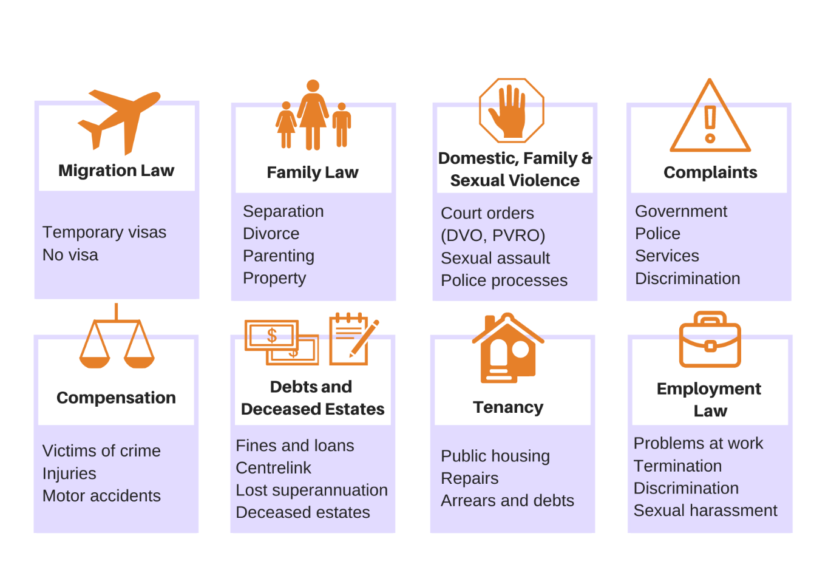
Please circle all relevant issues:
Any other information:

